Non-Disclosure Agreement
(Mutual)

NON-DISCLOSURE AGREEMENT (MUTUAL)

This Mutual Non-disclosure Agreement (the “Agreement”) is entered into this day of 21st, Nov., 2020 by and between *************************************** (Company A) , with an address at ***************************************** ,
and LAVA Limited. (Company B), with an address at Top floor, Building 8, Huihao Industrial Park, Jin’an Road Guangming, Shenzhen, China. 518106

***************************************** (Company A)
and LAVA Limited. may each be referred to from the time to time herein as a “Party”, and may collectively be referred to herein as the “Parties”.

WHEREAS, In connection with a proposed possible transaction or arrangement or investment opportunity (the “Possible Transaction”) that Parties desire to discuss, Company A and Company B will be mutually disclosing confidential information to each other.

THE PURPOSE OF THIS AGREEMENT IS FOR

In all cases, whether or not such information is designated as confidential (all such information, whether conveyed orally or in any tangible medium or gathered by inspection, hereafter referred to as “Confidential Information”).

NOW, THEREFORE, the parties hereto agree as follows:

- Confidential Information
  - For the purposes of this Agreement, the term “Confidential Information” shall not include any portion of such information that: (i) is or becomes generally known or available by publication, commercial use or otherwise through no fault of receiving party; (ii) is known and has been reduced to tangible form by the receiving party at the time of disclosure as proven by documentary evidence and is not subject to restriction; (iii) is independently developed or learned by the receiving party as proven by documentary evidence; (iv) is lawfully obtained from a third party that has the right to make such disclosure as proven by documentary evidence; or (v) is made generally available by disclosing party without restriction on disclosure.
  - The execution of this Agreement and the existence of any business negotiations, discussions, consultations or agreements in progress between the parties shall be considered Confidential Information, unless otherwise agreed by the parties hereto.
  - Each party shall use reasonable efforts to designate Confidential Information as “Confidential,” “Proprietary” or a similar designation denoting confidentiality: (i) by stamp or legend if communicated in writing or other tangible form; or (ii) orally at the time of disclosure.
  - Notwithstanding the foregoing, any failure by the disclosing party to indicate in writing or orally that a communication includes Confidential Information shall not give the receiving party the right to treat any information disclosed to the receiving party in such communication as not being Confidential Information that is subject to the confidentiality restrictions set forth in this Agreement unless the totality of the circumstances under which such communication was made would compel a reasonable person to conclude that the communication could not have been made by disclosing party with the intention that it would be treated as Confidential Information that is subject to the confidentiality restrictions set forth in this Agreement.
  - Each party shall not disclose Confidential Information to third parties without the express permission of disclosing party. Information designated as Confidential Information shall remain confidential until disclosing party designates it as non-confidential.

- No Disclosure
  - Each party shall hold and maintain Confidential Information in strictest confidence for the sole and exclusive benefit of disclosing party. Each party shall carefully restrict access to Confidential Information to employees, contractors and third parties as is reasonably required and shall require those persons to sign nondisclosure restrictions at least as protective as those in this Agreement.
  - Each party agrees to take all steps reasonably necessary to protect the secrecy of the Confidential Information and to prevent the Confidential Information from falling into the public domain or into the possession of unauthorized persons.
  - Each party shall not, without prior written approval of disclosing party, use for receiving party’s own benefit, publish, copy, or otherwise disclose to others, or permit the use by others for their benefit or to the detriment of disclosing party, any Confidential Information. Each party agrees not to use the Confidential Information in any way or manufacture or test any product embodying Confidential Information, except for the purpose authorized by disclosing party.
  - Each party shall return to disclosing party any and all records, notes, and other written, printed, or tangible materials in its possession pertaining to Confidential Information immediately if disclosing party requests it in writing.

- Term and Termination
  - The non-disclosure provisions of this Agreement shall survive the termination of this Agreement and each party’s duty to hold Confidential Information in confidence shall remain in effect until the Confidential Information no longer qualifies as a trade secret, until the Confidential Information is no longer confidential, or until disclosing party sends receiving party written notice releasing receiving party from this Agreement, whichever occurs first.
  - Each party agrees to return all documents and property to disclosing party, including but not necessarily limited to: legal documents, reports, manuals, correspondence, computer programs, and all materials and all copies thereof relating in any way to disclosing party’s business, or in any way obtained by either party during the course of business. Each party further agrees that it shall not retain copies, notes or abstracts of the foregoing.
  - This Agreement will continue in full force and effect for so long as either party continues to provide Confidential Information. This Agreement may be terminated by either party at any time upon 30 days’ written notice to the other party. The termination of this Agreement will not relieve Recipient of the obligations imposed by Paragraphs 2, 3, and 5 of this Agreement with respect to Confidential Information disclosed prior to the effective date of such termination and the provisions of those Paragraphs will survive the termination of this Agreement.
- Breach
  - Any breach or threatened breach by either party of any provision of this agreement will, because of the unique nature of the confidential information entrusted to receiving party as aforesaid, cause irreparable harm to the disclosing party and shall entitle disclosing party, in addition to any other legal remedies available to disclosing, to specific performance of receiving party’s obligations under this Agreement, and such further relief as may be granted by a court of competent jurisdiction.
- Severability
  - If one or more provisions in this Agreement are ruled entirely or partly invalid or unenforceable by any court of competent jurisdiction in any jurisdiction, then (a) the validity and enforceability of all provisions not ruled to be invalid or unenforceable shall remain unaffected; (b) the effect of such ruling shall be limited to the jurisdiction of the court making the ruling; (c) the provision(s) held wholly or partly invalid or unenforceable shall be deemed amended, and the parties shall reform the provision(s) to the minimum extent necessary to render them valid and enforceable in conformity with the parties’ intent as manifested herein; and (d) if the ruling, or the controlling principle of law or equity leading to the ruling, is subsequently overruled, modified, or amended, then the provision(s) in question, as originally set forth in this Agreement, shall be deemed valid and enforceable to the maximum extent permitted by the new controlling principle of law or equity.
- Governing Law
  - This Agreement shall be governed by, construed and enforced solely and exclusively in accordance with the laws of China without reference to conflict of law principles. Any and all disputes under this Agreement must be brought solely and exclusively in the city courts located in Shenzhen, China, and the parties hereby irrevocably consent to the personal jurisdiction and venue of these courts. This Agreement may not be amended except by a writing signed by both parties.
- Waiver
  - The failure to exercise any right provided in this Agreement shall not be a waiver of prior or subsequent rights. This Agreement and each party’s obligations shall be binding on the representatives, assigns and successors of such party. Each party has signed this Agreement through its authorized representative.
- Survival of Rights and Obligations
  - Neither party will assign or transfer any rights or obligations under this Agreement without the prior written consent of the other party. Any attempted assignment or transfer in violation of the foregoing shall be null and void.
- Entire Agreement
  - This Agreement represents the sole, final and entire agreement between the parties with respect to the subject matter hereof and shall supersede all prior or contemporaneous agreements and communications of the parties, oral or written.

IN WITNESS WHEREOF, the parties hereto have caused this Agreement to be executed by their respective duly authorized representatives below.

LAVA LIMITED
Signature: 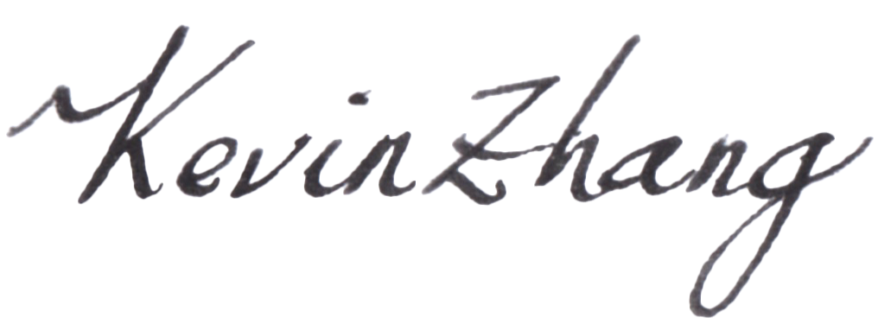
Print Name: Kevin Zhang
Title: CEO & FOUNDER
Date: Friday, January 29, 2021

****************************
Signature: **************************
Print Name: ***********************
Title: ***********************
Date: Friday, January 29, 2021

